# TCI SignUp Steps:

1. Access ‘cloud.tibco.com’
2. Click on ‘Try Now’ option



1. Select ‘ TIBCO Cloud Integration’ Free trail option with AWS

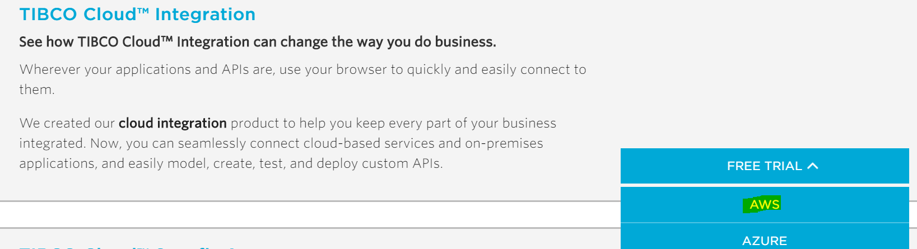

1. Fill the required details and signup

Note : If you already signup for trail and account expired, try with new ‘Emai ID’.

# GitHub code repo:

Clone or download the below Gitrepo to the desktop

https://github.com/mrachapa/Flogo_Workshop.git

# Rest Rating App

1. Login to TCI with ‘United States ‘ as region.

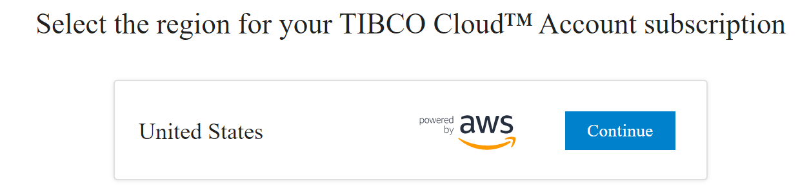

1. Select ‘Integration’ in TCI Dashboard and Click Flogo.

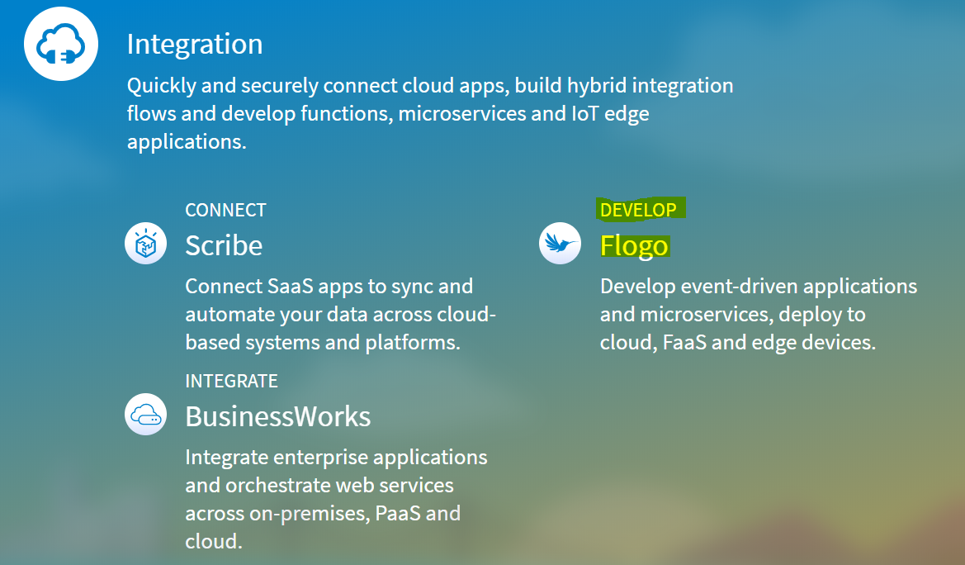

1. Click on ‘Create’ app

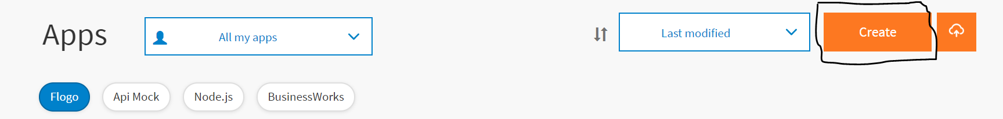

1. In Create App screen ,enter the name of app .

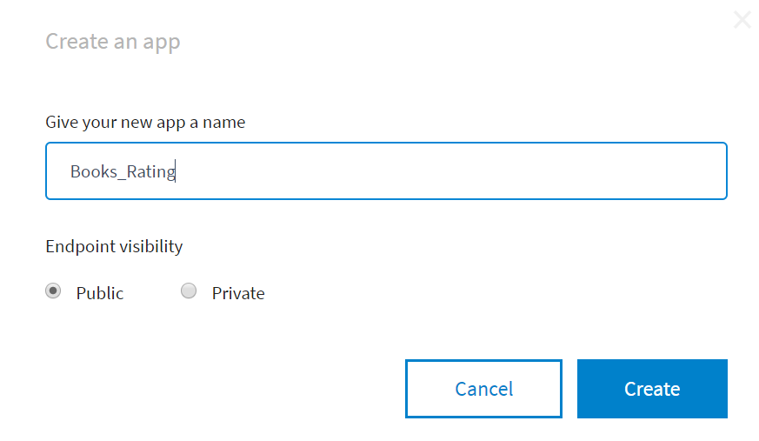

1. Select “Create a TIBCO Flogo App’ as shown below.

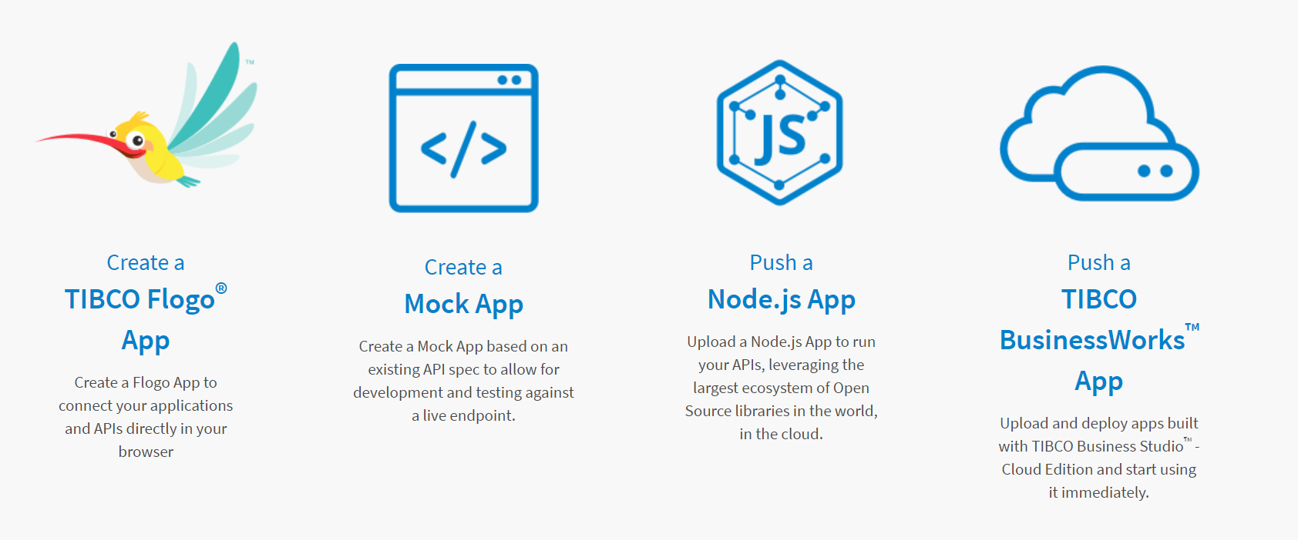

1. Select ‘ Import app’ option

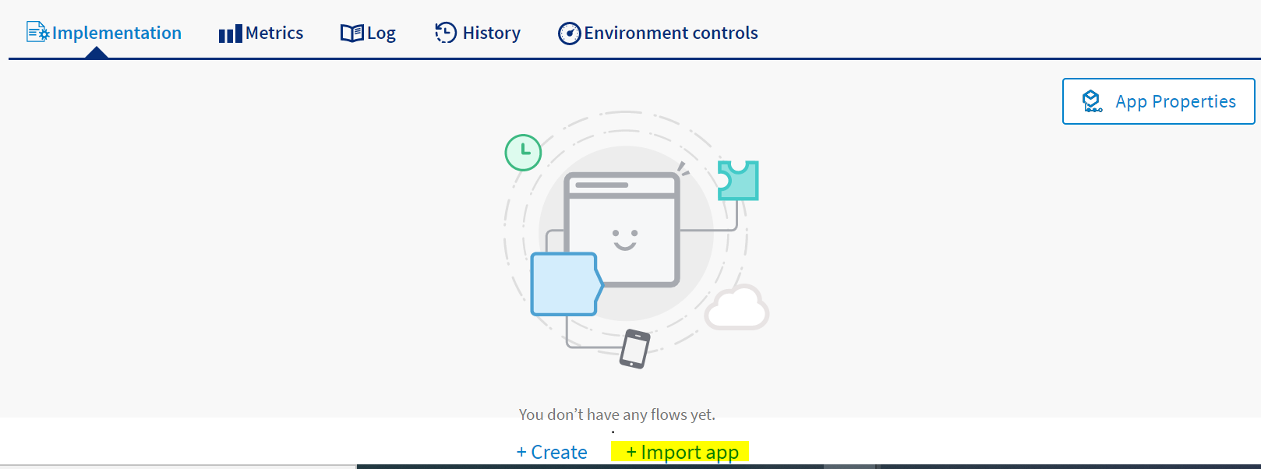

1. Browse and upload the ‘Books_RatingAPI.json’ file ,downloaded from gtihub .

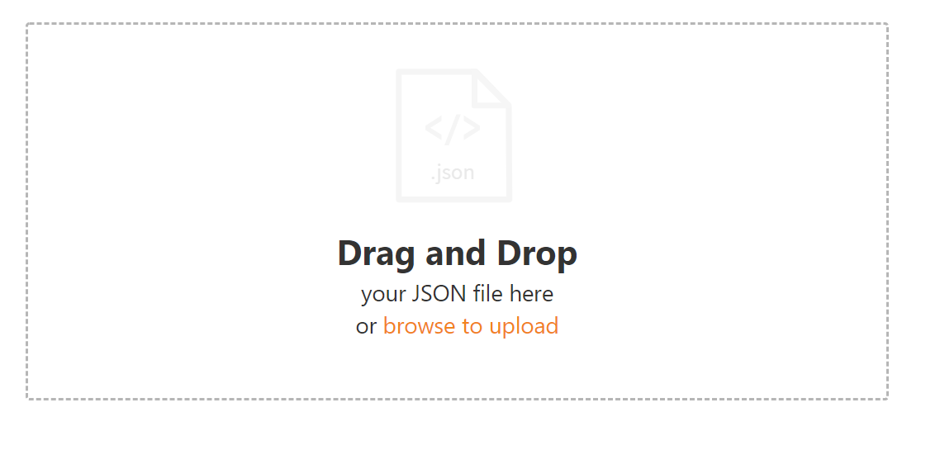

1. Ignore the warnings and click ‘Import all’ .

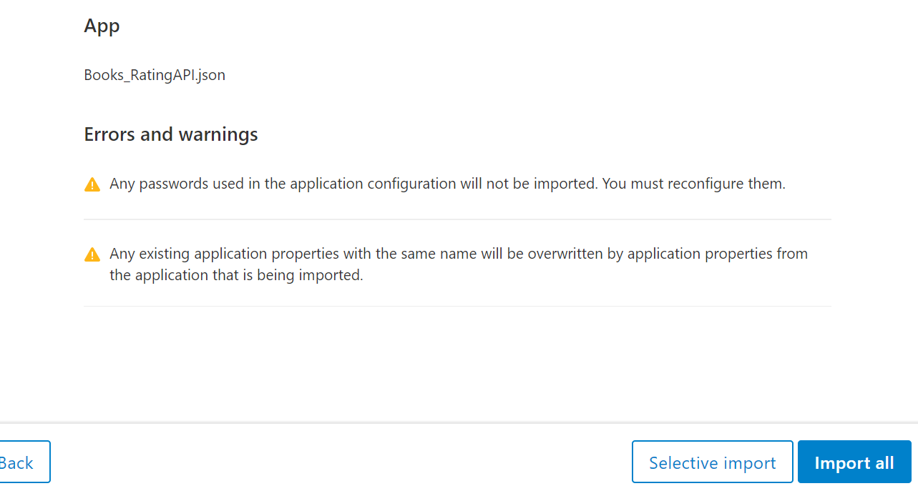

1. Click on ‘Push app’ for deployment.
2. Once app deployment successful ‘click on view and Test’ endpoint and test with ‘book_id’ as 1 or 2.

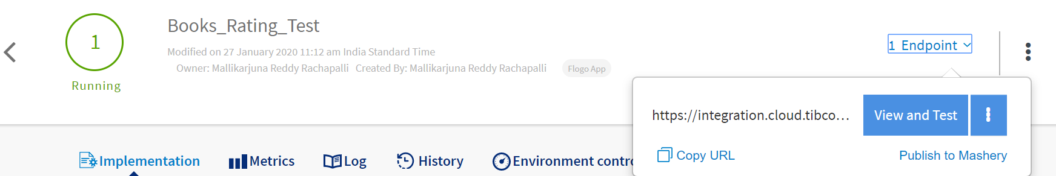

1. Copy the endpoint with ‘Copy URL’ option save to notepad.

# Currency Converter App

Repeat the steps mentioned in above section from “c- k” and while importing the app select

“ CurrencyConverter.json” file.

After pushing app to deployment copy the endpoint to Notepad.

# Book App

Repeat the steps mentioned in above section from “c- k” and while importing the app select

“ Books.json” file.

Click on ‘App preoperties’.

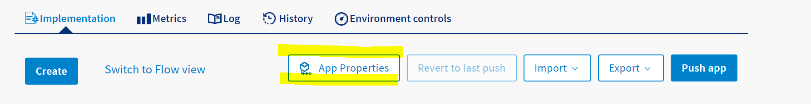

Update the endpoints copied from above two sections.

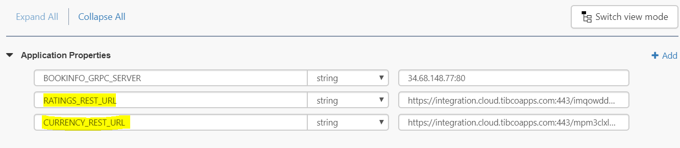

Testing:

Click on ‘Start Testing ‘

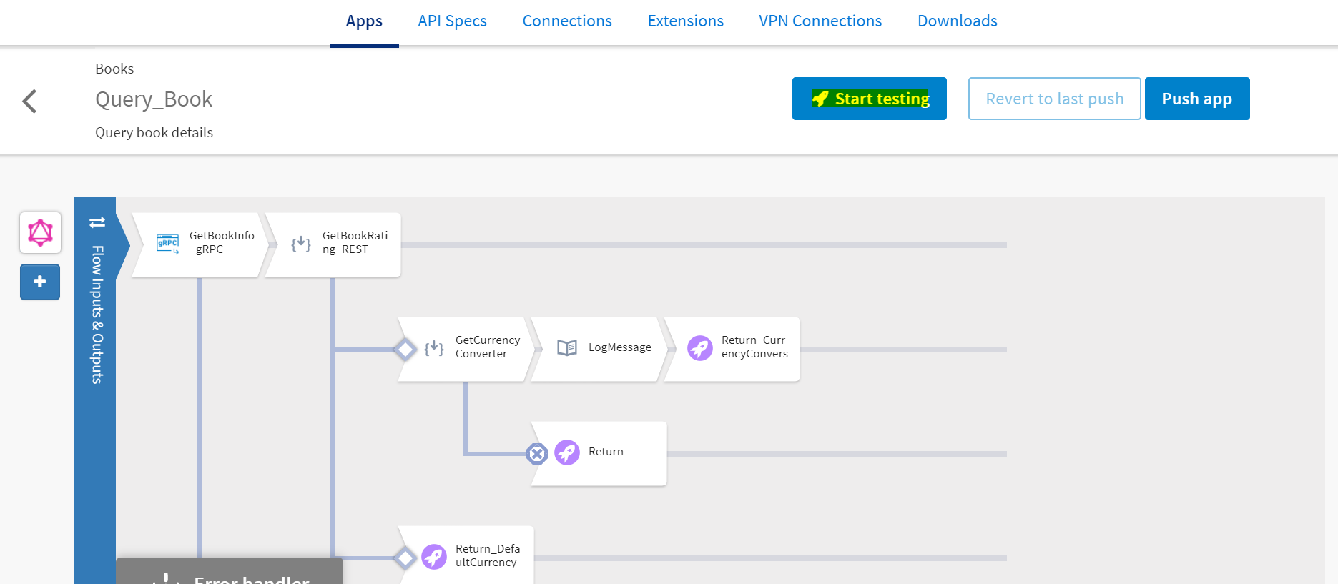

Create launch Configurations.

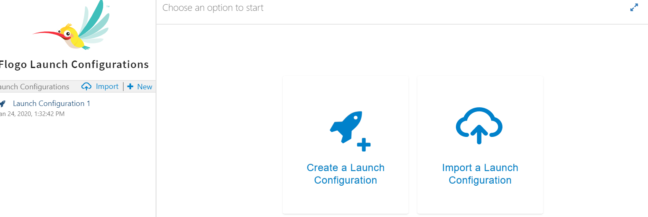

Pass the Valid Values to ‘id’ and ‘Currency’ fields.

